1A) Write a program where client can send a message to the server and the server can receive
the message and send, or echo, it back to the client.

SERVER:

import socket

HOST='127.0.0.1'
PORT=2053

with socket.socket(socket.AF_INET,socket.SOCK_STREAM) as s:
s.bind((HOST,PORT))
s.listen()
conn,addr=s.accept()

with conn:
print('Connection by',addr)
while True:
data=conn.recv(1024)
if data:
print("Client: ",data.decode())
data=input("Enter message to client: ")
if not data:
break

conn.sendall(bytearray(data,'utf-8'));

conn.close()

CLIENT:

import socket

HOST='127.0.0.1'
PORT=2053

with socket.socket(socket.AF_INET,socket.SOCK_STREAM) as s:
s.connect((HOST,PORT))
s.sendall(b'Hello,world')
data=s.recv(1024)
print("Received connection")
print("server",data.decode())

o/p:

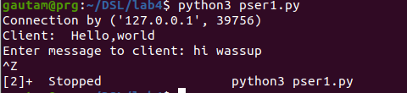

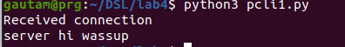
2A) Write a program to create TCP time server in Python

SERVER:

import socket as s
import time

serversocket=s.socket(s.AF_INET,s.SOCK_STREAM)

host=s.gethostname()

port=9991

serversocket.bind((host,port))

serversocket.listen(5)

while True:
clientsocket,addr=serversocket.accept()
print("Got a connection from %s"%str(addr))
currentTime=time.ctime(time.time())+"\n"
clientsocket.send(currentTime.encode('ascii'))
clientsocket.close()

CLIENT:

import socket as s

sock=s.socket(s.AF_INET,s.SOCK_STREAM)

host=s.gethostname()
port=9991

sock.connect((host,port))
tm=sock.recv(1024)
print('Current time from Server:',tm.decode())
sock.close

o/p:

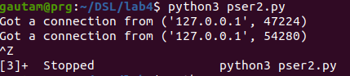
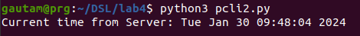
3A) Write a TCP chat server in python using socket programming.

SERVER:

import socket

HOST = '127.0.0.1'
PORT = 31621

s = socket.socket()
s.bind((HOST, PORT))
s.listen()

print("\nWaiting for incoming connections...\n")
conn, addr = s.accept()

print("Received connection from ", addr[0], "(", addr[1], ")\n")

s_name = conn.recv(1024)
s_name = s_name.decode()

print(s_name, "has connected to the chat room\nEnter [e] to exit chat room\n")
name = input(str("Enter your name: "))

conn.send(name.encode())

while True:
message = input(str("Me : "))
if message == "[e]":
message = "Left chat room!"
conn.send(message.encode())
print("\n")
break
conn.send(message.encode())
message = conn.recv(1024)
message = message.decode()
print(s_name, ":", message)

CLIENT:

import socket

HOST = '127.0.0.1'
PORT = 31621

s = socket.socket()

name = input(str("\nEnter your name: "))
print("\nTrying to connect to ", HOST, "(", PORT, ")\n")

s.connect((HOST, PORT))
print("Connected...\n")

s.send(name.encode())
s_name = s.recv(1024)
s_name = s_name.decode()

print(s_name, "has joined the chat room\nEnter [e] to exit chat room\n")
while True:
message = s.recv(1024)
message = message.decode()
print(s_name, ":", message)
message = input(str("Me : "))
if message == "[e]":
message = "Left chat room!"
s.send(message.encode())
print("\n")
break
s.send(message.encode())

O/P:

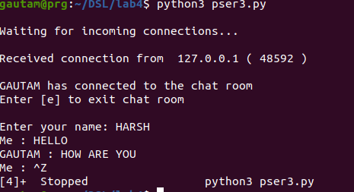
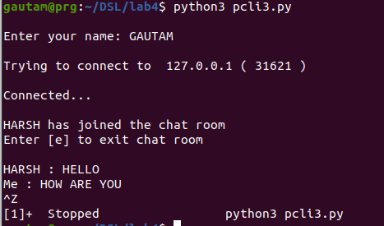
4A. Forking/ Threading (Concurrent Server)

SERVER:

import socket
import os
from _thread import *

ServerSocket = socket.socket()
host = '127.0.0.1'
port = 11596

ThreadCount = 0

try:
ServerSocket.bind((host,port))
except socket.error as e:
print(str(e))

print('Waitiing for a Connection..')
ServerSocket.listen(5)

def threaded_client(connection):
connection.send(str.encode('Welcome to the Server'))
while True:
data = connection.recv(2048)
print('Received from client :' + str(ThreadCount) +data.decode())
Inputs = input('Server Says: ')
if not data:
break
connection.sendall(Inputs.encode())
connection.close()

while True:
Client,address = ServerSocket.accept()
print('Connected to: ' + address[0] + ':' + str(address[1]))
start_new_thread(threaded_client, (Client, ))
ThreadCount += 1
print('Thread Number: ' + str(ThreadCount))
ServerSocket.close()

CLIENT:

import socket

ClientSocket = socket.socket()
host = '127.0.0.1'
port = 11596

print('Waiting for connection')

try:
ClientSocket.connect((host, port))
except socket.error as e:
print(str(e))

Response = ClientSocket.recv(1024)
while True:
Input = input('Client Say Something: ')
ClientSocket.send(str.encode(Input))
Response = ClientSocket.recv(1024)
print('From Server : ' + Response.decode())

ClientSocket.close()

O/P:

